**Exploração de dados**

import pandas as pd

import matplotlib.pyplot as plt

import numpy as np

from sklearn.model_selection import train_test_split

from sklearn.linear_model import LinearRegression

from sklearn.metrics import mean_absolute_error, mean_squared_error

teste_csv = pd.read_csv('car_rental_data.csv')

teste_df = pd.DataFrame(teste_csv)

remov_dupli = teste_df.drop_duplicates(keep="last")

remov_vlr_null = teste_df.dropna(thresh=2)

duplicatas = teste_csv.duplicated()

X_simple = remov_vlr_null[['purchase_value']]

y = remov_vlr_null['selling_value']

X_train, X_test, y_train, y_test = train_test_split(X_simple, y, test_size=0.2, random_state=42)

model_regression = LinearRegression()

model_regression.fit(X_train, y_train)

y_pred = model_regression.predict(X_test)

mae = mean_absolute_error(y_test, y_pred)

mse = mean_squared_error(y_test, y_pred)

mae_percentage = (mae / y_test.mean()) * 100

mse_percentage = (mse / y_test.mean()) * 100

print("Erro Médio Absoluto (MAE):", mae)

print("Erro Quadrático Médio (MSE):", mse)

print("Porcentagem de Erro MAE:", mae_percentage, "%")

print("Porcentagem de Erro MSE:", mse_percentage, "%")

plt.figure(figsize=(10, 6))

plt.scatter(X_test, y_test, color='blue', label='Valor Real', alpha=0.5)

plt.plot(X_test, y_pred, color='red', label='Valor Previsto', alpha=0.5)

plt.xlabel('Valores Reais')

plt.ylabel('Previsões')

plt.title('Valores Reais vs Previsões')

plt.legend()

plt.show()

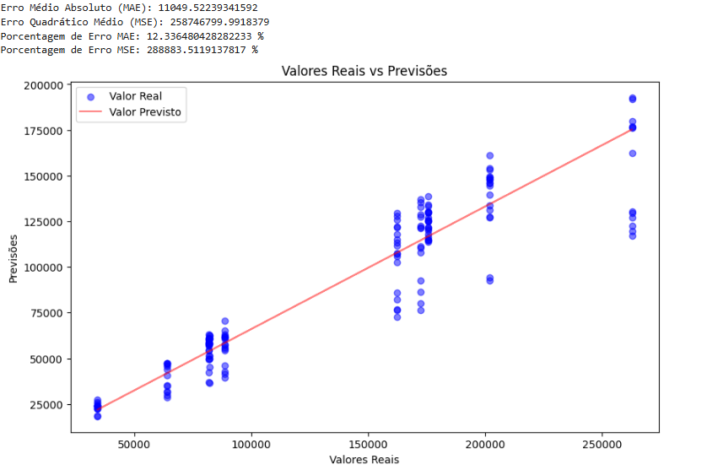

**Implementação e aprendizado**

import pandas as pd

import matplotlib.pyplot as plt

import numpy as np

from sklearn.model_selection import train_test_split

from sklearn.linear_model import LinearRegression

from sklearn.metrics import mean_absolute_error, mean_squared_error

from sklearn.neighbors import KNeighborsClassifier

from sklearn.metrics import accuracy_score, precision_score, recall_score, f1_score, confusion_matrix

import seaborn as sns

import matplotlib.pyplot as plt

teste_csv = pd.read_csv('car_rental_data.csv')

teste_df = pd.DataFrame(teste_csv)

remov_dupli = teste_df.drop_duplicates(keep="last")

remov_vlr_null = teste_df.dropna(thresh=2)

duplicatas = teste_csv.duplicated()

y_classification = pd.cut(remov_vlr_null['purchase_value'], bins=3, labels=['baixo', 'médio', 'alto'])

X_simple =remov_vlr_null [['selling_value']]

X_train, X_test, y_train, y_test = train_test_split(X_simple, y_classification, test_size=0.2, random_state=42)

model_knn = KNeighborsClassifier(n_neighbors=5)

model_knn.fit(X_train, y_train)

y_pred = model_knn.predict(X_test)

accuracy = accuracy_score(y_test, y_pred)

precision = precision_score(y_test, y_pred, average='weighted')

recall = recall_score(y_test, y_pred, average='weighted')

f1 = f1_score(y_test, y_pred, average='weighted')

print("Acurácia:", accuracy)

print("Precisão:", precision)

print("Recall:", recall)

print("F1-score:", f1)

cm = confusion_matrix(y_test, y_pred)

sns.heatmap(cm, annot=True, fmt="d", cmap="Blues", cbar=False)

plt.xlabel('Predicted labels')

plt.ylabel('True labels')

plt.title('Matriz de Confusão')

plt.show()

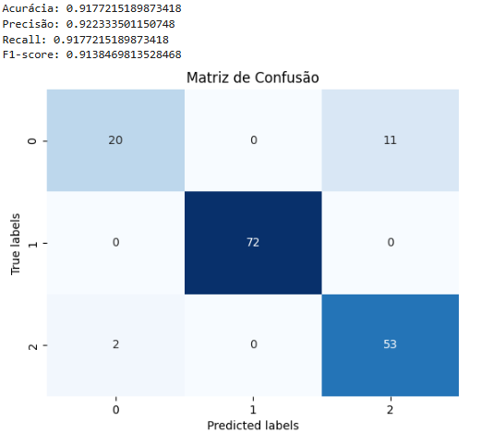

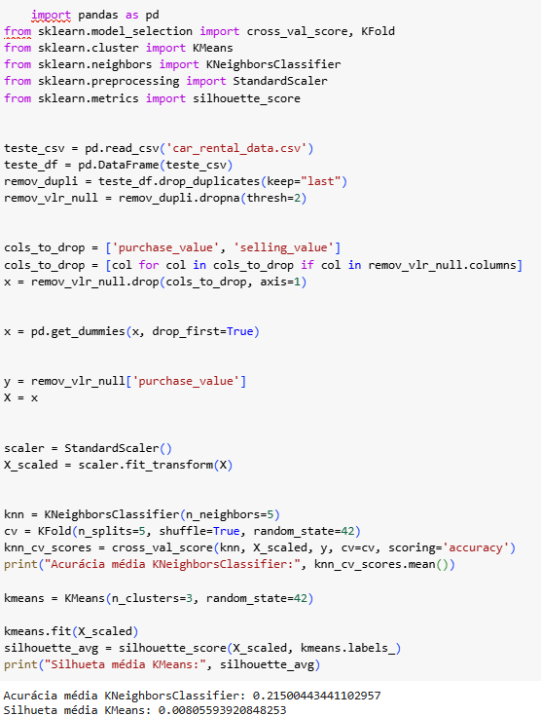

**Otimização**

import pandas as pd

import seaborn as sns

import matplotlib.pyplot as plt

from sklearn.cluster import KMeans

from sklearn.preprocessing import StandardScaler

import numpy as np

teste_csv = pd.read_csv('car_rental_data.csv')

teste_df = pd.DataFrame(teste_csv)

remov_dupli = teste_df.drop_duplicates(keep="last")

remov_vlr_null = remov_dupli.dropna(thresh=2)

print("Colunas disponíveis:", remov_vlr_null.columns)

cols_to_drop = ['purchase_value', 'selling_value']

cols_to_drop = [col for col in cols_to_drop if col in remov_vlr_null.columns]

x = remov_vlr_null.drop(cols_to_drop, axis=1)

x = pd.get_dummies(x, drop_first=True)

scaler = StandardScaler()

x_scaled = scaler.fit_transform(x)

n_cluster = 3

kmeans = KMeans(n_clusters=n_cluster, random_state=42)

kmeans.fit(x_scaled)

remov_vlr_null['cluster'] = kmeans.labels_

print('Centro dos Clusters')

print(scaler.inverse_transform(kmeans.cluster_centers_))

plt.figure(figsize=(10,6))

for cluster in range (n_cluster):

    cluster_data = remov_vlr_null[remov_vlr_null['cluster'] == cluster]

    plt.scatter(cluster_data['purchase_value'],cluster_data['segment'],label=f'cluster {cluster}')

plt.title ('Clusters de dados de segmento')

    plt.xlabel('purchase_value')

    plt.ylabel('segment')

    plt.legend()

    plt.show()

